BHMS Fine Arts Boosters
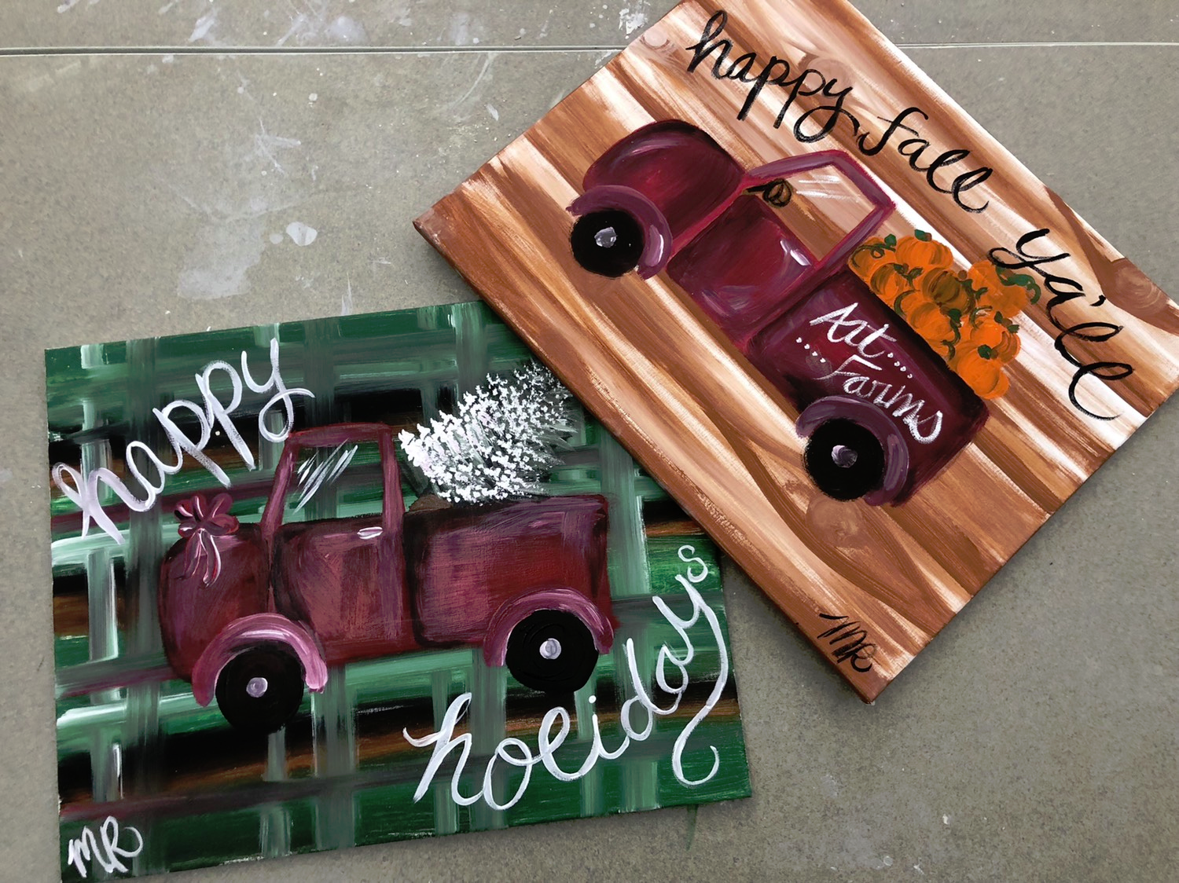
Family Paint Night
The Fine Arts Boosters is excited to invite you to Family Paint Night! Join us for a fun and creative night out with your family and friends. We will supply all the tools to create your masterpiece, you supply the creativity! Each painter will create one canvas painting.

Date: Thursday, October 25, 2018
Time: 6:30-8:30 pm
Location: BHMS Multipurpose Room/Cafeteria
Instructor: Meghan Ryan, BHMS Art Teacher
Please enter through the activity doors.

Bake sale and water available for purchase.

Proceeds benefit BHMS Fine Arts students, teachers and activities.

Reservations are awarded on a first-come, first-served basis. We have 70 spots that will fill up fast. Please place your order early.

No ticket necessary. Your name will be on the reservation list at the door.

We will be using acrylic paints which will stain. Be sure to wear your painting clothes or bring a smock.

Return bottom portion of this form with your cash or check.
------------------------------------------------------------------------------------------------------------------
Make checks payable to BHMS Fine Arts Boosters. Return form and check to Middle School Office, Attention: Julie Dee by Tuesday, October 23.

$20 per painter (paint brushes, paint, and canvas provided)
Reservation Name (First/Last)
Number of painters: | X $20 each = Total Amt.

